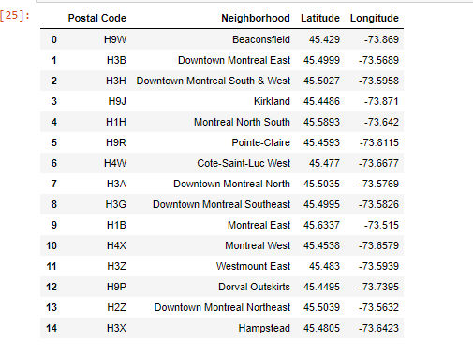

The Battle of Neighborhoods

Finding a location for a Vietnamese restaurant in Montreal

Enea Groballi | Applied Data Science | 1/22/2020

# Introduction: Business Problem

In this project we will try to find an optimal location for a Vietnamese Restaurant in Montreal, Canada.

We will try to detect locations that aren't already crowded with restaurants and we are especially interested in areas that aren't crowded with Vietnamese Restaurants. We would prefer if the location is close to the center of the city, assuming the first two conditions are met.

We will be using data science tools to find a few promising neighborhoods where we can open the Vietnamese Restaurant based on the criteria.

# Data

The factors below are what is going to influence our decision:

* Number of any type of restaurant in neighborhood
* Number of Vietnamese restaurants in neighborhood
* Distance of neighborhood from city center

We decided to just use a database found on [https://worldpostalcode.com/canada/quebec/montreal](https://worldpostalcode.com/canada/quebec/montreal%20) for our neighborhoods that are linked to the postal codes. We will also need to use the following data sources:

* Google Maps Api Geocoding to get latitude and longitude
* Restaurant data from Foursquare API

# Data Cleaning

* Created dataframe with the neighborhoods and Lat and Lng



* Find center of the city

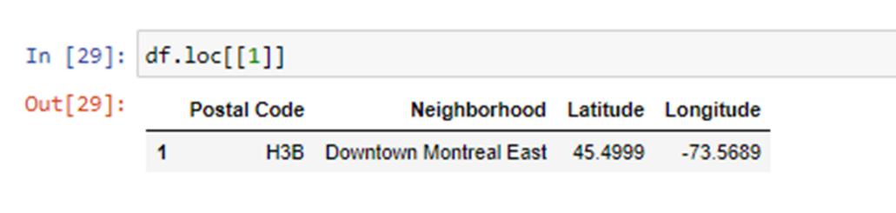

# Visualization

* Create the map of downtown Montreal

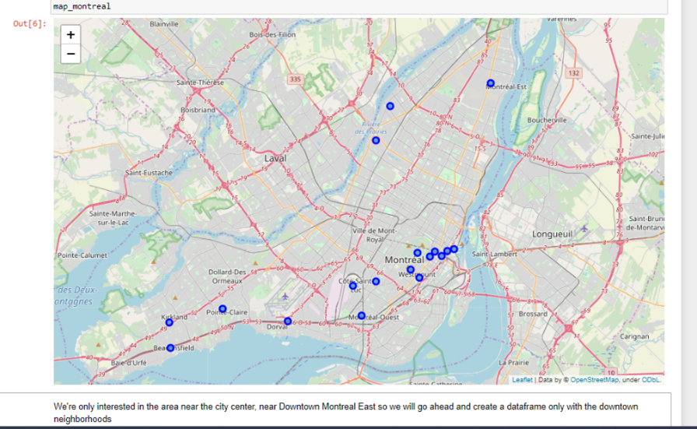

* We’re only interested in the area near the city center, near Downtown Montreal East so we will go ahead and create a dataframe and map with only downtown neighborhoods

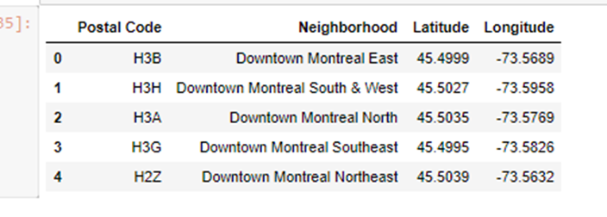

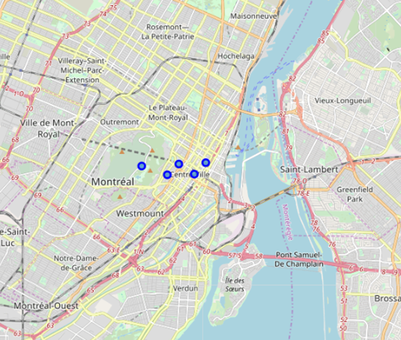

# Foursquare API

* We use Foursquare API and we get the Venues information where we can see how many of each of the categories of venues, we have in these neighborhoods. We do not see any Vietnamese Restaurants

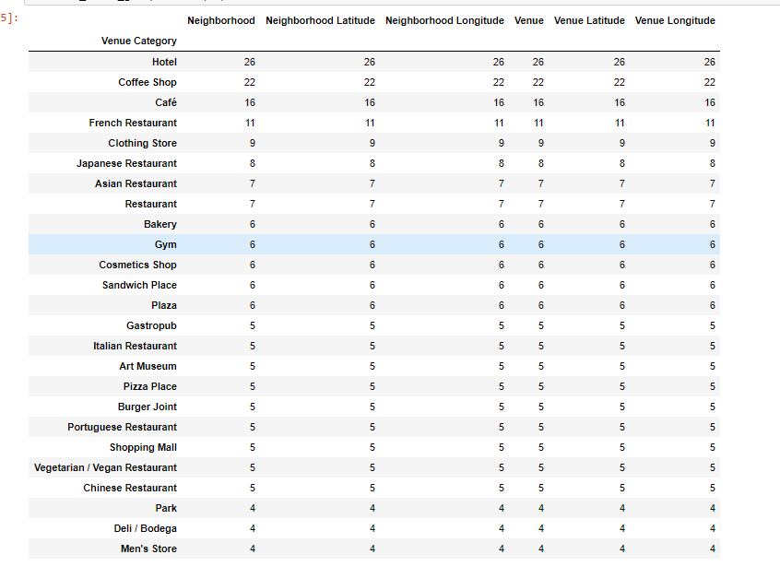

# Analyzing each neighborhood

* We see in the data that restaurants are top venues in 4 out of the 5 neighborhoods

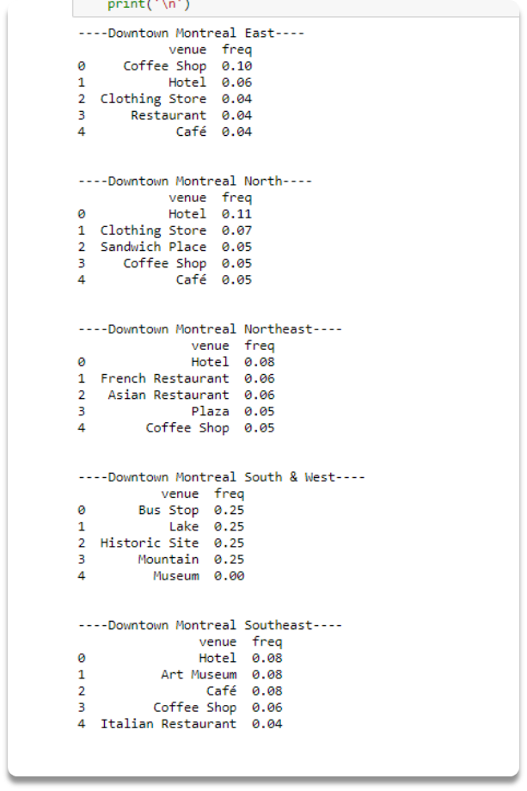

# Results and Conclusion

